Task 13: API Testing Using Postman
Internship: Cyber Security Internship
Name: Adil Firoz
Date: 6 February 2026
Operating System: Ubuntu / Kali Linux
Tools Used: Postman, JSONPlaceholder Public API, Web Browser
Objective
The objective of this task was to understand and perform basic API testing using Postman. This included sending GET and POST HTTP requests to a public REST API and analyzing the responses.
Tools Used
- Operating System: Ubuntu / Kali Linux
- Tool: Postman
- API Used: JSONPlaceholder (Public Test API)
- Procedure
- Step 1: Launch Postman
- Postman was successfully installed and opened. A new workspace was created to organize API requests.
Screenshot 1: Postman Dashboard / Workspace
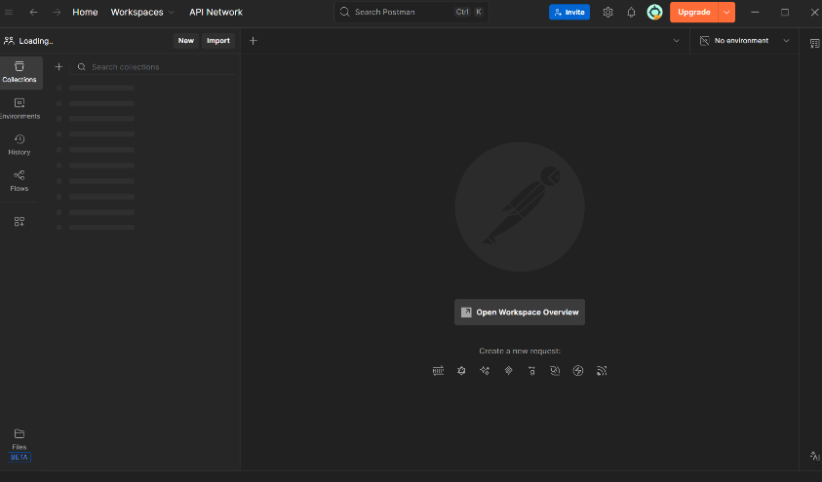
Step 2: GET Request (Retrieve Data)
A GET request was sent to fetch data from the API.
Endpoint:
https://jsonplaceholder.typicode.com/posts/1
Method: GET
Result:
The API returned a JSON response containing post details such as userId, id, title, and body, confirming successful data retrieval.
Screenshot 2: GET Request with Successful Response
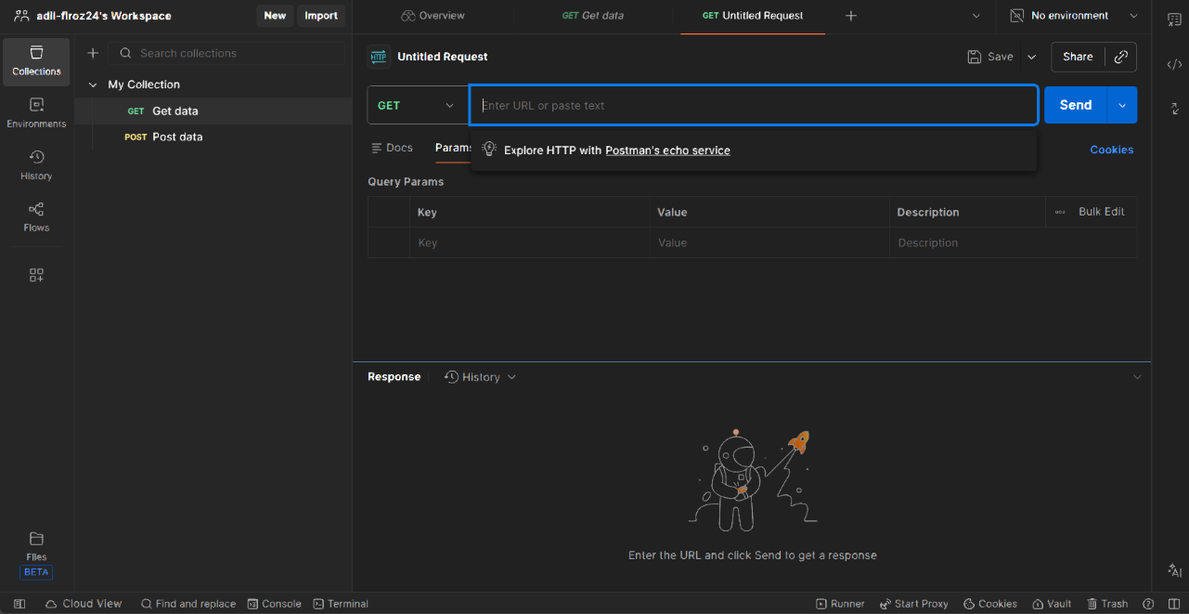
Step 3: POST Request (Send Data)
A POST request was used to send data to the API.
Endpoint:
https://jsonplaceholder.typicode.com/posts
Method: POST
Result:
The server responded with HTTP Status Code 201 (Created) and returned a JSON object containing a newly created resource ID.
Screenshot 3: POST Request with 201 Created Response
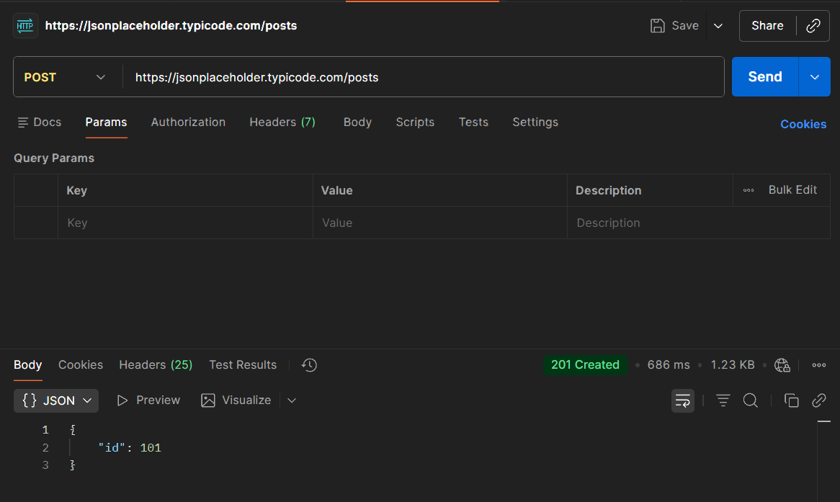
Step 4: Error Handling (404 Response)
An invalid or non-existing resource was requested using a GET request.
Result:
The server returned HTTP Status Code 404 (Not Found), demonstrating proper error handling by the API.
Screenshot 4: GET Request Showing 404 Not Found
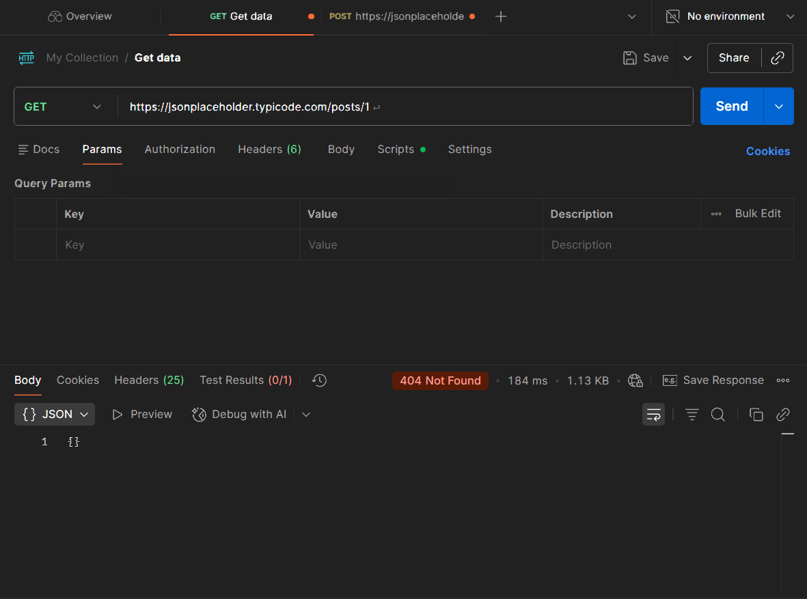
Results
- Successfully tested GET and POST API requests.
- Received correct HTTP status codes (200/201/404).
- Verified API responses in JSON format.
- Understood how Postman is used for API testing and debugging.

Conclusion
This task provided hands-on experience with API testing using Postman. It helped in understanding RESTful APIs, HTTP methods, status codes, and response validation. The task was completed successfully, and all objectives were achieved.

